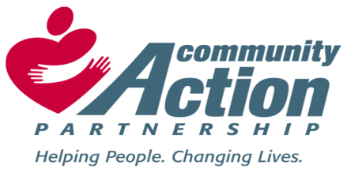
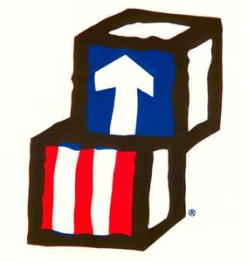

Bolivar County Community Action Agency, Inc. Elnora Littleton, Executive Director
Eastgate Center, Suite 120 Head Start/ Early Head Start Director
810 East Sunflower Road
Cleveland, MS 38732
Phone: 662-846-1491
Fax: 662-843-0173
Email: alambert@bolivarcaa.org

TO: ALL EMPLOYEES
FROM: Dr. Regina Spivey, Human Resources Director/Trainer
RE: JOB VACANCIES
DATE: September 8, 2021
Bolivar County Community Action Agency, Inc. has the following job openings:

COMMUNITY SERVICES CASE MANAGER (1)
Plans and implements the activities of the CSBG/LIHEAP programs in accordance with the Division of Community Services guidelines as directed by the Program Director. Case Management, Interviews, Assessments, Monitors and Excellent Customer Service.
- BS Degree in Social Work or a related field required.
- One (1) years’ experience in Case Management.

FAMILY SERVICES - PARENT ENGAGEMENT COORDINATOR (1)
Serves as the Lead Case Manager, maintaining accurate ERSEA reports, guiding the implementation of the parenting curriculum, and assisting with program planning, policy development and training. Contributes to program improvement through evaluation, self-assessment, and other program develop efforts. Trains and supervises the Family Service Worker.
- BS Degree in Social Work or a related field required.
- MS License Required and one (3) years’ experience working with families and case management.

FAMILY SERVICES WORKER (1)
Assist in planning and implementing the activities of the department including parent activities and training designed to enhance family support and advocacy along with parent activities and training designed to enhance family support and advocacy under the supervision of the Family Services/ERSEA Director and the Family Services Parent Engagement Coordinator.
- BS Degree in Social Work or a related field required.
- One (1) years’ experience working with families.

ESG-CV LEAD/CASE WORKER (1)-Rapid Re-Housing (this position is for 1 year)
This position implements the activities of the ESG-CV Program (working with the homeless) in accordance with the HUD and ESG-CV guideline. One of the primary responsibilities is to supervise Case Workers and HMIS Staff. Records Management, Community Outreach and Exceptional Customer Service are key components of this position. Must be willing to travel to Bolivar, Sunflower, Coahoma, Leflore, and Washington Counties.

- AA Degree in Social Work or a related field required.
- Two (2) years’ experiences in Case Management and Supervision required.

ESG-CV CASE WORKER (1)-Rapid Re-Housing (this position is for 1 year)
This position implements the activities of the ESG-CV Program in accordance with the HUD and ESG-CV guidelines (working with the homeless). The primary source is to implement case management and to help clients obtain housing and become self-sufficient. Case Management, Data Entry, Records Management, Community Outreach and Exceptional Customer Service are key components of this position. Must be willing to travel to Bolivar, Sunflower, Coahoma, Leflore, and Washington Counties.

- AA Degree in Social Work or a related field required.
- One (1) years’ experience in Case Management required.

ESG-CV HMIS LEAD/Case Worker (1)-Rapid Re-Housing (this position is for 1 year)
This position implements the activities of the ESG-CV Program in accordance with the HUD guidelines (working with the homeless)). The HMIS Lead will enter confidential information into the program’s database. Compliance, Supervision, Reporting, Case Management, Data Entry, Records Management, Community Outreach and Exceptional Customer Service are key requirements of this position. Must be willing to travel to Bolivar, Sunflower, Coahoma, Leflore, and Washington Counties.
- AA Degree in Business Administration or a related field required.
- One (1) years’ experience in Case Management is required.

Bolivar County Head Start/Early Head Start Program has the following job opening:

BUS DRIVER (2) – Cleveland and Rosedale, MS
Transport children to and from the center while following safety and DOT driving regulations. Maintain discipline on the bus and inspect and report maintenance needs.
- High School Diploma Preferred.
- Commercial Driver’s License with P & S Endorsements required.
- The ability to read and write required.
- One (1) years’ experience driving a bus required.
- Complete or possess an up-to-date Bus Driver Training Certificate.

Must be able to pass a criminal background check, physical and drug screen. Mandatory COVID-19 Required.

DEADLINE TO APPLY – September 22. 2021
Please submit a cover letter of interest, resume and three (3) professional references via email to: alambert@bolivarcaa.org. The deadline to apply is September 22, 2021.

BCCAA provides equal employment opportunities to all employees and applicants for employment and prohibits discrimination and harassment of any type without regard to race, color, religion, age, sex, national origin, disability status, genetics, protected veteran status, sexual orientation, gender identity or expression, or any other characteristic protected by federal, state or local laws.

