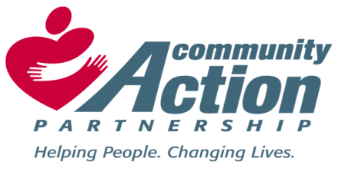

Bolivar County Community Action Agency, Inc. Elnora Littleton, Executive Director
Eastgate Center, Suite 120 Head Start/ Early Head Start Director
810 East Sunflower Road
Cleveland, MS 38732
Phone: 662-846-1491
Fax: 662-843-0173
Email: rspivey@bolivarcaa.org

TO: GENERAL PUBLIC
FROM: Dr. Regina Spivey, Human Resources Director/Trainer
RE: JOB VACANCIES
DATE: May 21, 2021 (Run Dates: 05/26 & 06/02/21)
Bolivar County Community Action Agency, Inc. has the following job openings:

CSBG/LIHEAP SOCIAL WORKER (2)
Plans and implements the activities of the CSBG/LIHEAP programs in accordance with the Division of Community Services guidelines as directed by the Program Director.
Case Management, Interviews, Assessments, Monitors and Excellent Customer Service.

- BS Degree in Social Work or a Related Field.

FAMILY SERVICES LICENSED SOCIAL WORKER (1)
Plans and implements the activities of the department along with parent activities and training designed to enhance family support and advocacy as directed by the Department Director.

- BS Degree in Social Work or a Related Field.
- MS License Required and one (1) years’ experience working with families.

Bolivar County Head Start/Early Head Start Program - Rosedale Center
EARLY HEAD START CAREGIVER (1)
Provides a comprehensive program of guidance, direction and meaningful classroom experience designed to meet the individual needs of each student in accordance with ACYF and Early Head Start Performance Standards.

- A.A. Degree in Early Childhood Development or a related field and experience working with young children.

Must be able to pass a criminal background check, physical and drug screen.

DEADLINE TO APPLY
Please submit a cover letter of interest, resume and three (3) professional references via email to: rspivey@bolivarcaa.org. The deadline to apply is June 9, 2021.

