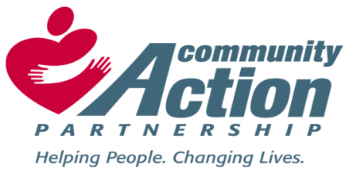

Bolivar County Community Action Agency, Inc. Elnora Littleton
Eastgate Center, Suite 120 Executive Director
810 East Sunflower Road Head Start/ Early Head Start Director
Cleveland, MS 38732
Phone: 662-846-1491
Fax: 662-843-0173
Email: capdir@bolivarcaa.org

TO: THE GENERAL PUBLIC

FROM: LAVERNE FRANKLIN – INTERIM HUMAN RESOURCE DIRECTOR

RE: JOB VACANCIES

DATE: MARCH 18, 2021

Please be advised that there is a job vacancy in the Bolivar County Community Action Finance Department as listed below:

1 – INVENTORY ACCOUNTANT

Duties and Responsibilities
- Monitors and maintains current inventory levels
- Processes purchasing orders as required
- Tracks orders and investigates any billing issues
- Responsible for the development and the disbursement of information as it relates to the bidding process
- Records purchases, maintains inventory database, and performs physical count of inventory
- Assist in the reconciliation of other agency financial accounts

MINIMUM QUALIFICATIONS:
BS Degree in Accounting/Business Administration or a related field; and three years’ experience working in the accounting field.

DEADLINE:
Cover letters along with Resumes and References can be sent to dataclk@bolivarcaa.org. The deadline for applying is April 2, 2021.

